**FORMAN CHRISTIAN COLLEGE (A CHARTERED UNIVERSITY)**



**Information Security**

**2023_FALL**

**Section B**

**Assignment#1**

**Aliza Khokhar - 241546728**

**Port Scanning**

**SCANNING Link 1:**

**Nmap & db nmap**

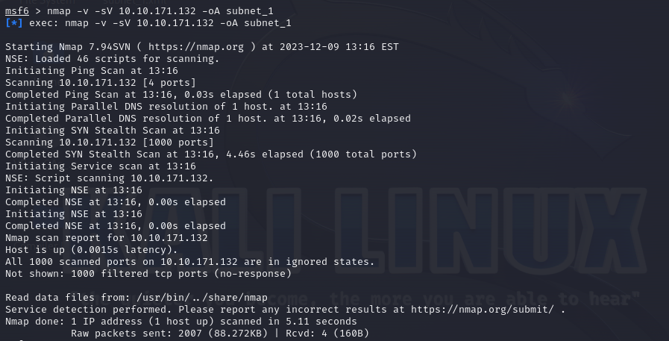

**Port Scanning:**

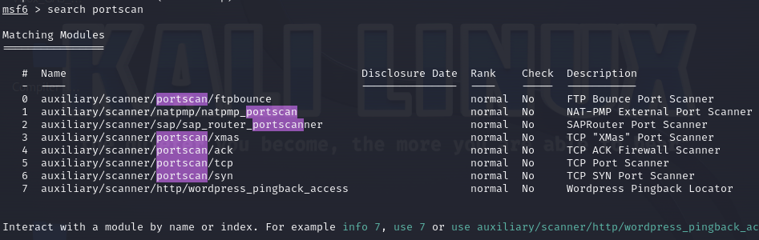



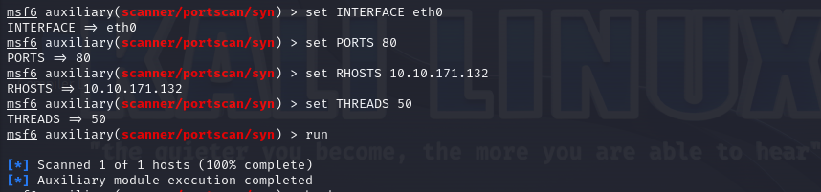

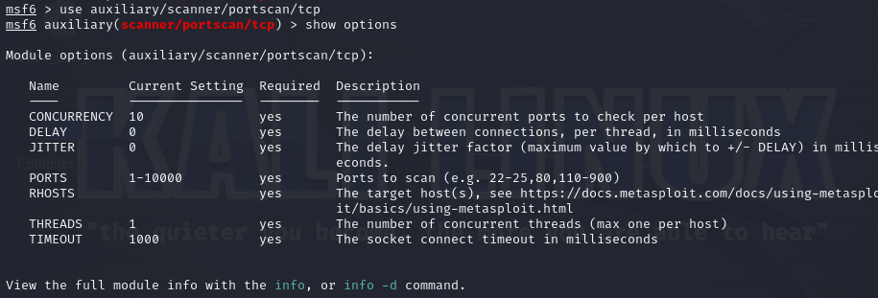

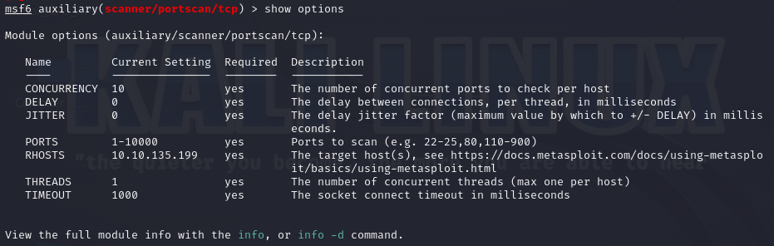





**SMB Version Scanning:**

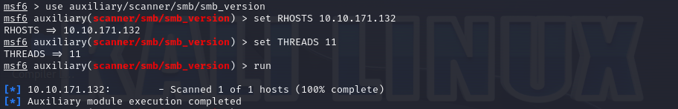





**Idle Scanning:**

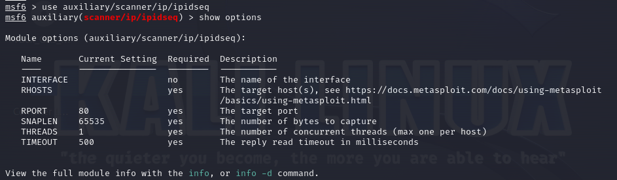

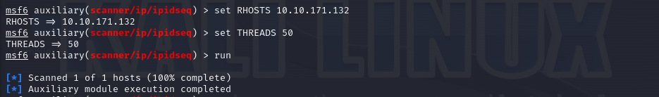

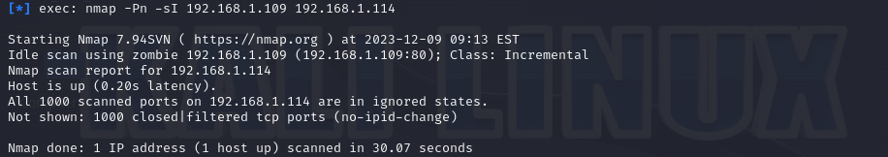

**Using Metasploit and Nmap to scan for vulnerabilities**

**Second Link**

**Scanning for open ports on the client machine with Metasploit:**

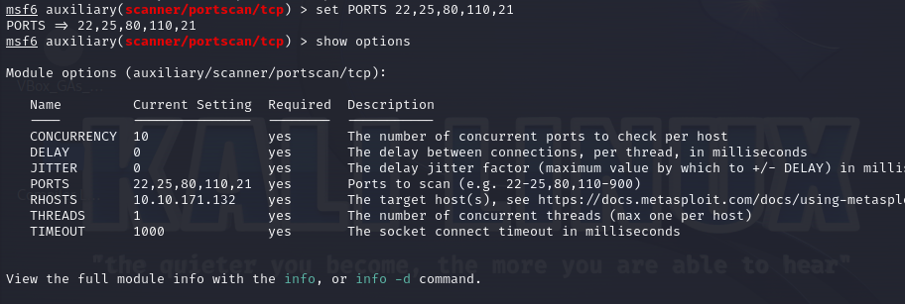

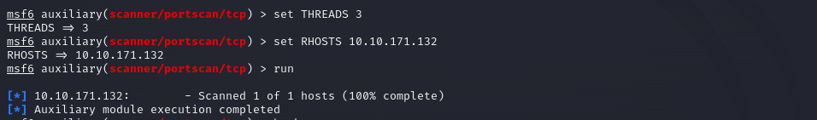

**Combining Nmap with Metasploit for a more detailed and in-depth scan on the client machine:**

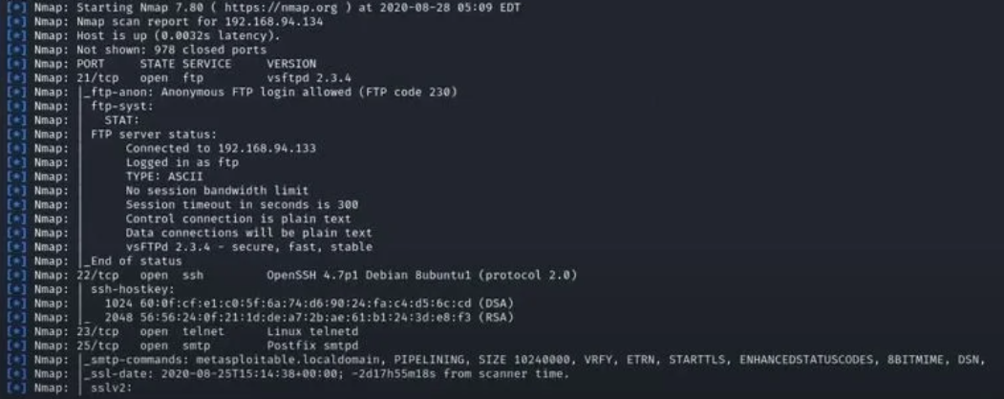

**Scanning for vulnerabilities with Nmap and Metasploit:**

